Task 1:

Create mat view log

create materialized view log on agr_trans

with primary key

including new values;

Create mat view:

create materialized view v_agr_trans

build immediate as

SELECT event_dt,

company_name

,ROUND ( AVG ( avg_pct )

, 2 ) avg_pct

, SUM ( sum_income ) sum_income

, COUNT ( count_trans ) count_trans

FROM u_dw_ext_references.agr_trans

GROUP BY event_dt, company_name;

Screenshot:

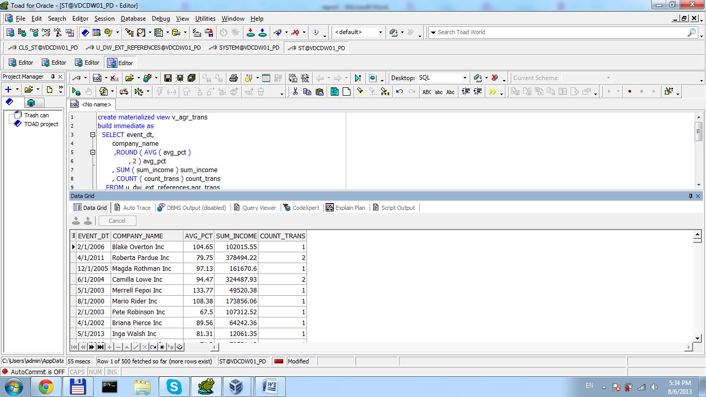

Check:

update agr_trans

set company_name = 'CHECK_VALUE'

where a_id = 5;

begin

***dbms_mview.refresh***('v_agr_trans', 'c');

end;

select * from v_agr_trans

where company_name = 'CHECK_VALUE';

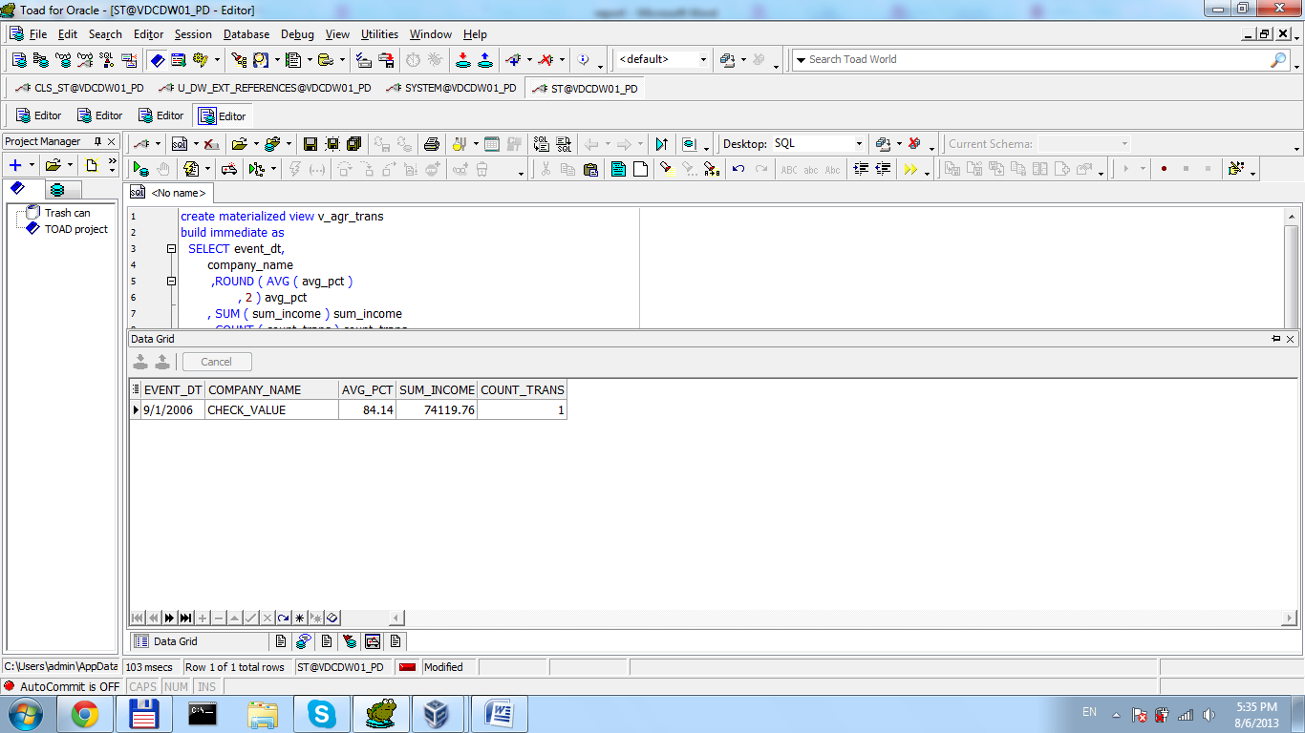

Task 2:

create materialized view v_agr_trans

build immediate

refresh on commit

as

SELECT a_id,event_dt,

company_name

, AVG ( avg_pct )

avg_pct

, count (avg_pct) avg_i

, SUM ( sum_income ) sum_income

, count(sum_income) summ

, COUNT ( count_trans ) count_trans

FROM u_dw_ext_references.agr_trans

GROUP BY a_id,event_dt, company_name;

View has some changes because there are some constraints on ‘on commit refresh’

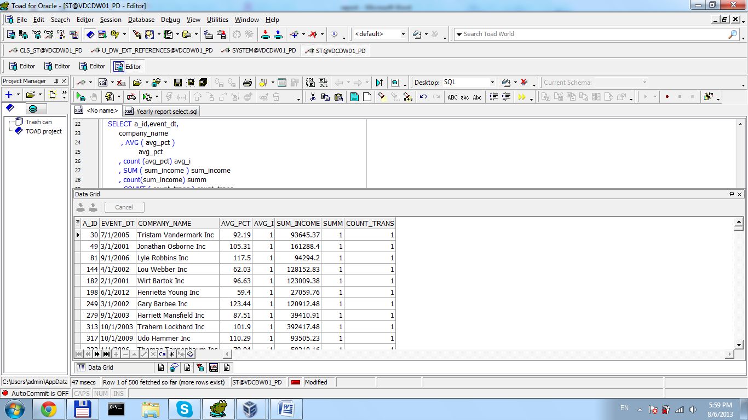

Check:

update agr_trans

set company_name = 'CHECK_VALUE1'

where a_id = 6;

commit;

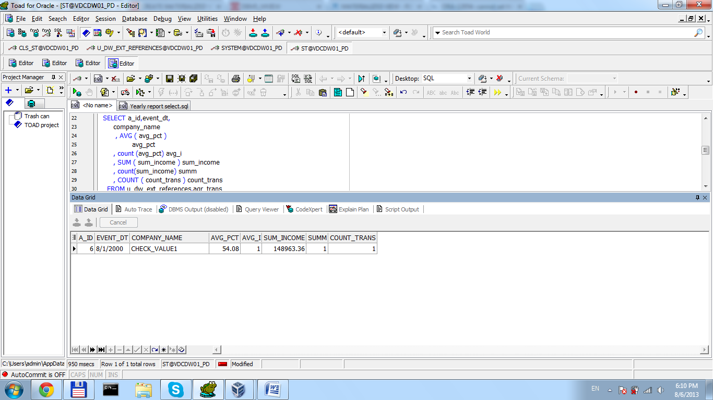

Task 3:

create materialized view v_agr_trans

build immediate

refresh start with sysdate next (sysdate + 1/180)

as

*/* Formatted on 8/6/2013 1:22:21 PM (QP5 v5.139.911.3011) */*

WITH temp AS ( SELECT TO_CHAR ( TRUNC ( t.tran_id

, 'MM' )

, 'Month' )

tran_id

, cust.company_name

, cust.cust_city

, p.port_identifier port_id

, AVG ( t.dep_goods / t.ar_goods ) * 100 pct

, SUM ( t.dep_goods * prod.income_coef ) income

, COUNT ( t.dep_goods ) cnt

FROM u_dw_ext_references.t_trans t

JOIN u_dw_ext_references.ext_products prod

ON ( t.prod_id = prod.prod_id )

JOIN u_dw_ext_references.ext_prod_categories cat

ON ( prod.prod_category_id = cat.prod_category_id )

JOIN u_dw_ext_references.ext_ship sh

ON ( t.ship_id = sh.ship_unique_identifier )

JOIN u_dw_ext_references.ports p

ON ( t.dep_port = p.port_identifier )

JOIN u_dw_ext_references.ports s

ON ( t.ar_port = s.port_identifier )

JOIN u_dw_ext_references.ext_insurances ins

ON ( t.ins_id = ins.unique_identifier )

JOIN u_dw_ext_references.ext_customers cust

ON ( t.cust_id = cust.customer_identifier )

WHERE TO_CHAR ( TRUNC ( t.tran_id

, 'YYYY' )

, 'YYYY' ) = '2011'

AND TO_CHAR ( TRUNC ( t.tran_id

, 'MM' )

, 'MM' ) = '01'

GROUP BY t.tran_id

, cust.cust_city

, p.port_identifier

, cust.company_name)

SELECT tran_id month

, company_name

, pct

, income

, cnt

FROM temp

MODEL

DIMENSION BY ( tran_id, company_name, cust_city, port_id )

MEASURES ( pct pct, income income, cnt cnt )

RULES

( pct [FOR tran_id IN

(SELECT tran_id

FROM temp), 'ALL_COMPANIES', NULL, NULL] = AVG ( pct )[CV ( tran_id ), company_name, ANY, ANY],

pct ['TOTAL', NULL, NULL, NULL] = AVG ( pct )[ANY, ANY, ANY, ANY],

income [FOR tran_id IN

(SELECT tran_id

FROM temp), 'ALL_COMPANIES', NULL, NULL] = SUM ( income )[CV ( tran_id ), company_name, ANY, ANY],

income ['TOTAL', NULL, NULL, NULL] = SUM ( income )[ANY, ANY, ANY, ANY],

cnt [FOR tran_id IN

(SELECT tran_id

FROM temp), 'ALL_COMPANIES', NULL, NULL] = SUM ( pct )[CV ( tran_id ), company_name, ANY, ANY],

cnt ['TOTAL', NULL, NULL, NULL] = COUNT ( pct )[ANY, ANY, ANY, ANY] )

Screenshots:

